**Mini Project Report on**



**CONTENT ANALYSIS**

**YOLO BASED VEHICLE COUNTING APPLICATION**



**Submitted in partial fulfillment of the requirement for the award of the degree of**

**BACHELOR OF TECHNOLOGY**

**IN**

**COMPUTER SCIENCE & ENGINEERING**

**Submitted by:**

**Student Name University Roll no**

**Jai Anand** **2016792**

***Under the Mentorship of***

**Dr Vikas Tripathi**

**Associate Dean (R&D)**

**Graphic Era Deemed to be University**



**Department of Computer Science and Engineering**

**Graphic Era (Deemed to be University)**

**Dehradun, Uttarakhand**

**January 2023**



**CANDIDATE’S DECLARATION**

I hereby certify that the work which is being presented in the project report entitled **“Content Analysis- Yolo based Vehicle Counting Application”** in partial fulfillment of the requirements for the award of the Degree of Bachelor of Technology in Computer Science and Engineeringof the Graphic Era (Deemed to be University), Dehradun shall be carried out by the under the mentorship of **Dr Vikas Tripathi, Associate Dean (Research &Development)**, Department of Computer Science and Engineering, Graphic Era (Deemed to be University), Dehradun.

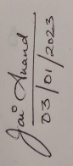

Jai Anand 2016792

Name University Roll no

**Table of Contents**

|  |  |  |
| --- | --- | --- |
| **Chapter No.** | **Description** | **Page No.** |
| Chapter 1 | Introduction |  |
| Chapter 2 | Literature Survey |  |
| Chapter 3 | Methodology |  |
| Chapter 4 | Result and Discussion |  |
| Chapter 5 | Conclusion and Future Work |  |
|  | References |  |

**Chapter 1**

**Introduction**

In the following sections, a brief introduction and the problem statement for the work has been included.

* 1. **Introduction**

Content analysis is a research tool used to determine the presence of certain words, themes, or concepts within some given qualitative data (i.e., text or image or video). Using content analysis researchers can quantify and analyze the presence of relationships of certain concepts and ideas. Researchers can then make inferences about the content within the files, even the culture and time of surrounding the text.

Humans’ glances at an image or a video and instantly know what objects are in latter. The human visual system is fast and accurate, allowing us to perform complex tasks like driving with little conscious thought. Fast and accurate algorithms for object detection would allow computers to interpret real time information and act accordingly to perform certain tasks. Current detection systems repurpose classifiers to perform detection. To detect an object, these systems take a classifier for that object and evaluate it at various locations and scales in a test image. Systems like deformable parts models (DPM) use a sliding window approach where the classifier is run at evenly spaced locations over the entire image.

* 1. **Object Detection Methods**

Generally, object detection methods are classified as either neural network-based or non-neural approaches. Also, some of them are rule-based, where the rule is predefined to match specific objects. Non-neural approaches require defining features using some feature engineering techniques and then using a method such as a support vector machine (SVM) to do the classification.

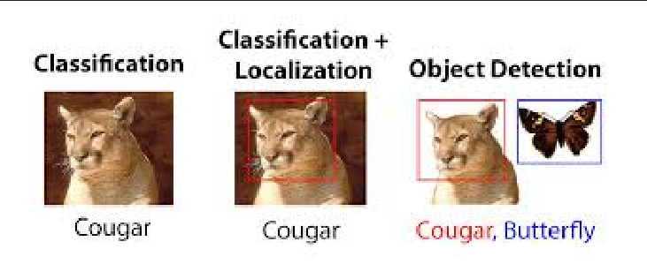

Fig 1.1) difference between classification, localization, and classification & Detection

Some of the non-neural methods are: -

1.2.) Viola-Jones object detection method based on Haar features.

1.2.2) Scale-invariant feature transform (SIFT)

1.2.3) Histogram of Oriented Gradients (HOG)

1.2.4) Other methods based on template, shape, or color matching

On the other hand, neural network techniques can do end-to-end object detection without explicitly defining features. They are far more accurate than non-neural based and are typically built on convolutional neural networks (CNN).

Some of the neural network methods are: -

1.2.5) Region-Based Convolutional Neural Networks (R-CNN, Fast R-CNN, etc.)

1.2.6) Single Shot Detector (SSD)

1.2.7) Retina-Net

1.2.8) You Only Look Once (YOLO)

* 1. **Project Motivation**

1.3.1) Traffic analysis: Vehicle counters can be used to collect data on the number of vehicles passing through a particular location over a given period. This data can be used to analyze traffic patterns and help with traffic management.

1.3.2) Transportation planning: Vehicle counters can be used to estimate the number of vehicles that use a particular road or highway, which can help with transportation planning and infrastructure development.

1.3.3) Environmental monitoring: Vehicle counters can be used to estimate the number of vehicles emitting pollutants in a particular area, which can help with environmental monitoring and policy development.

1.3.4) Revenue generation: Vehicle counters can be used to charge tolls on roads or highways based on the number of vehicles that pass through a particular location.

1.3.5) Safety: Vehicle counters can be used to monitor the number of vehicles on a road or highway, which can help with safety planning and incident response.

1.3.6) Marketing: Vehicle counters can be used to estimate the number of vehicles that pass by a particular location, which can be useful for businesses looking to advertise to a large audience.

**Chapter 2**

**Literature Survey**

**(2 to 3 pages)**

Discuss the latest research work done by various authors related to the proposed work.

**Chapter 3**

**Methodology**

Explain your methodology using phrases, flowcharts, detailed diagrams, etc.

**(2 to 3 pages)**

**Chapter 4**

**Result and Discussion**

This section will contain all your results from the above methodology used.

The result could be graphs, diagrams, tables, matrices, etc.

**Chapter 5**

**Conclusion and Future Work**

This section will contain the conclusion of your work. Further contains vision and ideas about future methods or new solutions to your current problem statement.

**References**

[1] N. K. Kanhere and S. T. Birchfied, “Real-time incremental segmentation and tracking of vehicles at low camera angles using stable features,” *IEEE Trans. Intell. Transp. Syst*., vol. 9, no. 1, pp.148-160, March 2008 **(Example : Journal papers)**

[2] K. Onoguchi, “Moving object detection using a cross correlation between a short accumulated histogram and a long accumulated histogram”, Proc. 18th Int. Conf. on Pattern Recognition, Hong Kong, August 20 - 24, 2006, vol. 4, pp. 896 – 899 **(Example : Conference papers)**

[3] T. H. Cormen, C. E. Leiserson, R. L. Rivest and C. Stein, “Introduction to Algorithms”, 2nd ed., The MIT Press, McGraw-Hill Book Company, 2001 **(Example : Text Book/ Magazine)**

[4]Open Source Computer Vision (OpanCV) [Online]. Accessed on 21st April 2022: <http://opencv.willowgarage.com/wiki/> **(Example : Website)**